***Syed Yusha Abbas Kazmi***

***BSIT***

***3A***

***To get familiar with logical operators and Conditional Structure and Loops***

**AI Lab no. 4**

**Input:**

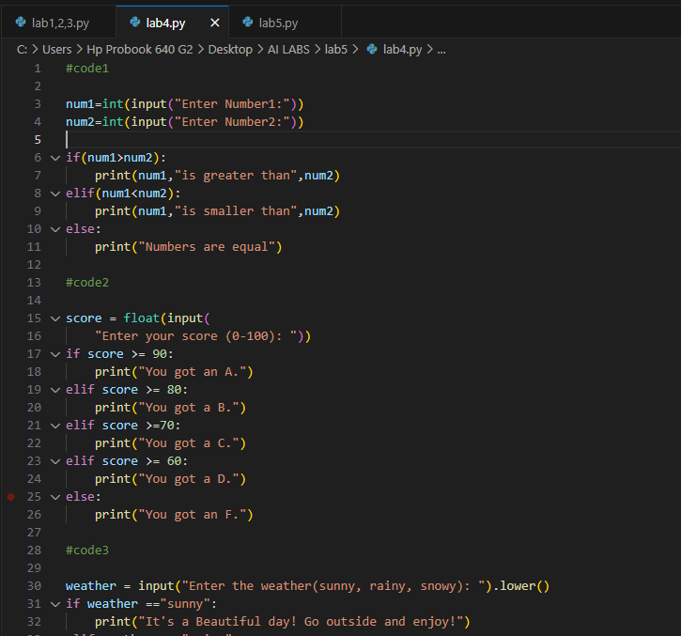

**Output:**

